이름 요약
(증빙사진)
Jonghun Lee(이종훈)
Professor
Department of Interdisciplinary Engineering
School of graduate

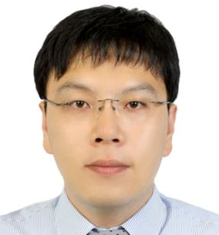
Sangdong Kim(김 상 동)
Assistant Professor
Department of Interdisciplinary Engineering
School of graduate

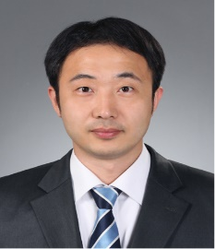
Bong-seok Kim(김봉석)
Ph. D
Senior researcher

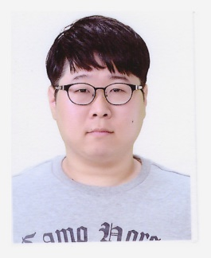Seungeon Song(송승언)
Researcher
Alumni
Cherl-Hee Lee, 이철희 박사(사진없음)
Jasurbek Khodjaev, 자수르 박사(사진 없음)

(증빙사진)

Jonghun Lee(이종훈)
Professor
Department of Interdisciplinary Engineering
School of graduate
Director & Principal Researcher,
Division of Future Automotive Research,
DGIST, Korea
DGIST (Daegu Gyeongbuk Institute of Science & Technology), 50-1, Sang-Ri, Hyeongpung-Myeon, Dalseong-Gun, Daegu, 711-873, Korea
Phone: 82-53-785-4580 Fax: 82-53-785-4589
Office: R4-Room205
Email: jhlee@dgist.ac.kr

Biography
Ph.D., Department of Electrical, Electronics and Computer Engineering, Sungkyunkwan University, 2002.
M.S., Department of Electronic Engineering, Sungkyunkwan University, 1998.
B.S., Department of Electronic Engineering, Sungkyunkwan University, 1996.
Samsung Electronics Co., Ltd., (March 2002 ∼ June 2005)
Principal Researcher, Telecom R&D Center, Telecommunication Systems Division

Georgia Institute of Technology (Oct. 2016 ∼ Oct. 2017)
Visiting scholar, Department of Electrical and computer Engineering

DGIST (July 2005 ∼ present)
Professor, Department of Interdisciplinary Engineering
Director & Principal researcher, Research Division of Future Automotive Research
Professor, Technical Venture Academy, School of graduate

Academic Activities
IEEE senior member
Vice President, KSS(The Korea Society for simulation)
Board & Editor Member, IEMEK(Institute of Embedded Engineering of Korea)

Research Interests
Radar Detection & Classification
Radar System Design
MIMO/Multi-channel Radar
Multifunctional Radar(MFR)
Multi-dimensional Imaging Radar
Super-resolution radar algorithm
Automatic Target Recognition
Machine learning & Deep learning Automotive Radar

Professional Experiences
130 papers published and presented and 90 patents filed
5 technologies transferred
Adjunct Professor, Yeungnam Univ., Daegu, Korea (2007.3. – 20011.12)

Awards and Honors
Award of minister of Trade, Industry & Energy in Korea (2015), Tech-Biz. Top 3
Award of minister of Science, ICT and Planning in Korea (2013), Outstanding performance
Man of DGIST of the year(2012)
Great minds of the 21st Century (ABI, 2012, 2013)
2000 outstanding intellectuals of the 21st Century (IBC, 2011)
Honor of Best researcher in DGIST(2007)
Best paper award in COOC(1999)

Name : 김 상 동 (Sangdong Kim)
Phone : +82-53-785-4561, Division of Automotive Technology/Senior Research Engineer
E-mail : kimsd728@dgist.ac.kr, DGIST (Daegu Gyeongbuk Institute of Science and Technology)

- 학력
Mar./13– Aug./18 | Ph.D. in Electrical Engineering, Kyungpook National Univ., Daegu, Korea  Thesis: Low complexity joint extrapolation-MUSIC based 2D parameter estimator for vital FMCW radar
Mar./04 – Feb./06 | M.S. in Electrical Engineering, Hanyang Univ., Seoul, Korea  Thesis: 802.15.4a Differentially Bi–Orthogonal Chirp-Shift-Keying (DBO-CSK) - Wireless Personal Area Network Coexistence Issues
Mar./00 – Feb./04 | B.S. in Electrical Engineering , Hanyang Univ., Ansan, Korea

- 연구 분야
Super-resolution radar
Vital sign radar
Automotive radar
MIMO imaging radar

- 경력
Jan./14 – Present Senior Research Engineer, Division of Automotive Technology, DGIST, Daegu, Korea
- Developed super-resolution algorithm for vehicle and human
- Implemented FMCW radar DSP system for vehicle and human
Oct./15 – Sep./16 Visiting Scholar, University of Florida, Florida, U.S.A
- Developed vital Doppler frequency estimation algorithm
Jan./06 – Dec./13 Research Engineer, Robotics Research Division, DGIST, Daegu, Korea
- Developed frequency estimator for pulse radar
- Implemented UWB radar prototype board composed of FPGA and DSP
Mar./04 – Feb./06 Research Assistant, Hanyang Univ., Seoul, Korea
- Implemented IEEE 802.15.3a MB-OFDM - UWB system
- Implemented IEEE 802.15.4a DBO-CSS system

- 수상
Nov./19, 임베디드공학회 우수논문상
Mar./14, 교육과학기술부 장관상
Sep./10, 대구경북과학기술원 공로상

Bong-seok Kim(김봉석)

He received his B.S. degree in department of electronics engineering in 2006 and the M.S. and Ph.D. degrees in department of information and communications Engineering of Yeungnam Univ., Korea, in 2009 and 2014, respectively.

Since 2014, he is currently working in Daegu Gyeongbuk Institute of Science & Technology (DGIST), Korea, as a senior research engineer.

His current interests include the multi-functional radar systems, radar signal processing and physical layer for 5G communication systems.

Email: remnant@dgist.ac.kr

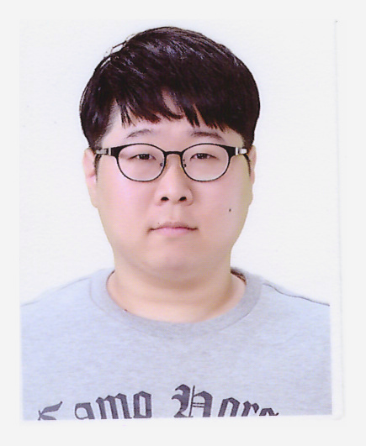Seungeon Song(송승언)
Division of Automotive Technology/Research Engineer
DGIST (Daegu Gyeongbuk Institute of Science & Technology) 50-1, Sang-Ri, Hyeongpung-Myeon, Dalseong-Gun, Daegu, 711-873, Korea
Phone : 82-53-785-4565
Fax :
Email : sesong@dgist.ac.kr
biography
M.S., Department of Electronic Engineering, Jeju National University, 2014.
B.S., Department of Electronic Engineering, Jeju National University, 2017.
research_interests
Radar System Design
Multifunctional Radar(MFR)
Super-resolution radar algorithm
Automotive radar

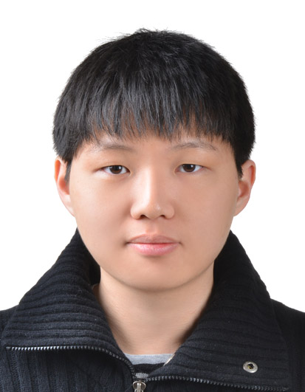
Division of Automotive Technology/Research Engineer
DGIST (Daegu Gyeongbuk Institute of Science & Technology) 50-1, Sang-Ri, Hyeongpung-Myeon, Dalseong-Gun, Daegu, 711-873, Korea

Phone : 82-10-9661-7466
Fax :
Email : silv93@dgist.ac.kr
biography
B.S., Department of interdisciplinary Engineering, Tokyo Institute of Technology 2019.

Research Interests
Radar gesture sensing
Motion recognition
Virtual Reality

